Danny Dinh

Comp 195

2/5/2022

Encryption Application: System Design

System Design Document: Contents and Format

**Cover page**

* Name: SAFSS ( Software Applications for Security Study)
* https://github.com/comp195/senior-project-spring-2022-encryption-project
* Danny Dinh ([q_dinh1@u.pacific.edu](mailto:q_dinh1@u.pacific.edu))
* 2/13/2022

**System Architecture**

Microservice model

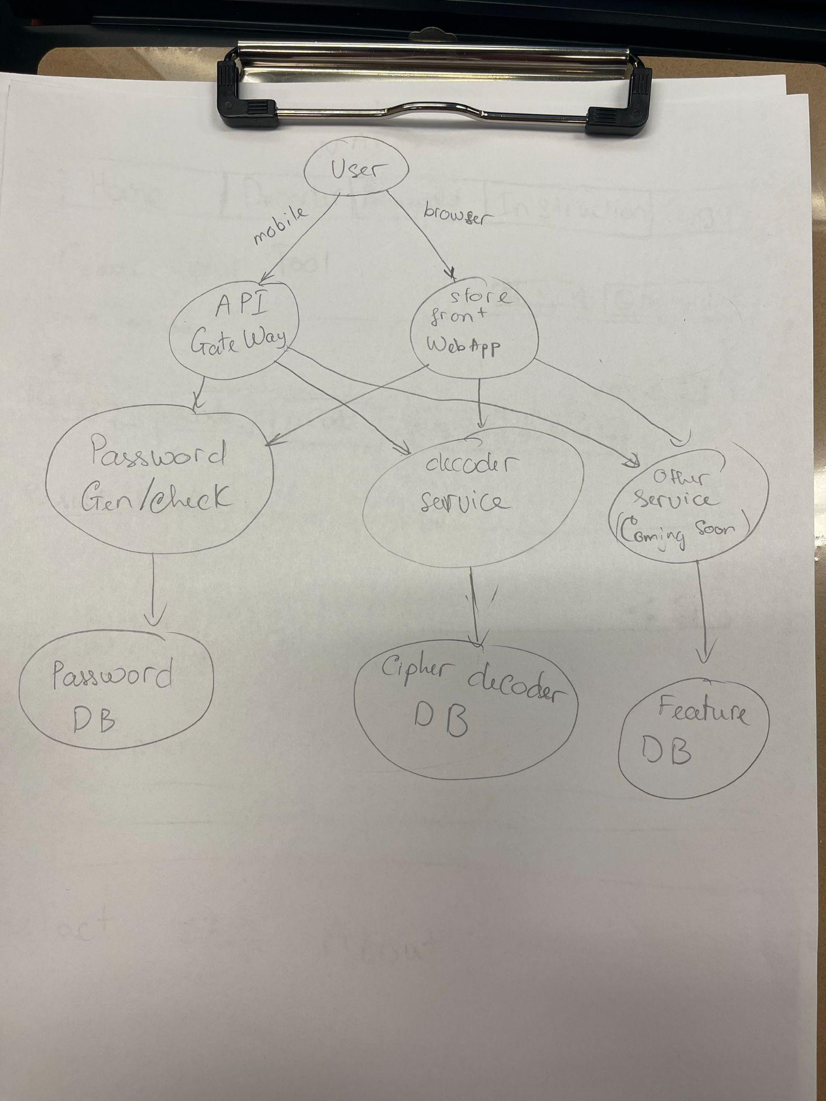

**Hardware, Software, and System Requirements**

Hardware requirements: the list below are minimum and recommended hardware requirements for WAFSS application.

| **Component** | **Minimum** | **Recommended** |
| --- | --- | --- |
| Processor | 1.9 gigahertz (GHz) x86- or x64-bit dual-core processor with SSE2 instruction set | 3.3 gigahertz (GHz) or faster 64-bit dual-core processor with SSE2 instruction set |
| Memory | 2-GB RAM | 4-GB RAM or more |
| Display | VGA with 800x600 resolution or higher | VGA with 1024 x 768 resolution or higher |

Browser/ Operating system: Below is a list of browser and operating system support and run the WAFSS application.

| Operation System | Browser |
| --- | --- |
| Window 10 and Window 11 | Chrome: Current Version  Microsoft Edge: Current Version  Firefox: Current Version  Internet Explorer: Explorer 11  Safari: Version 15.2 |
| MacOs 10.15 to 12 |
| Chrome OS: Current Version |

**Software Design**

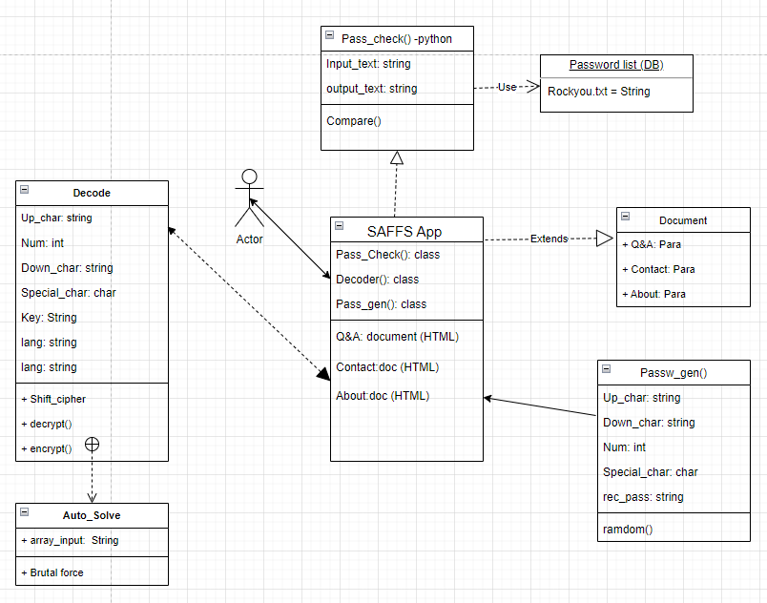

**User Interface Design**

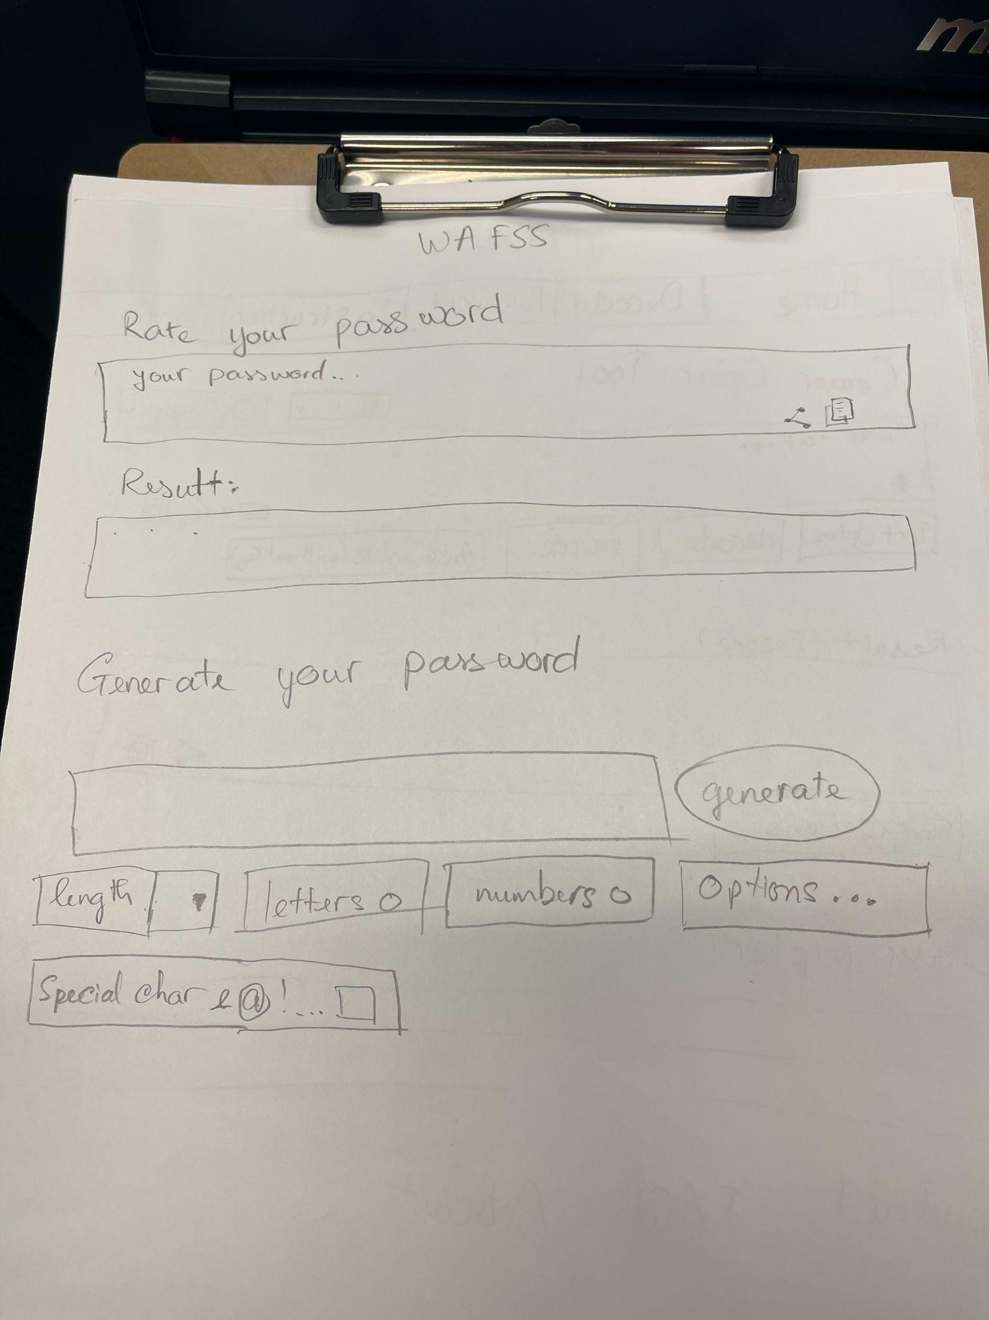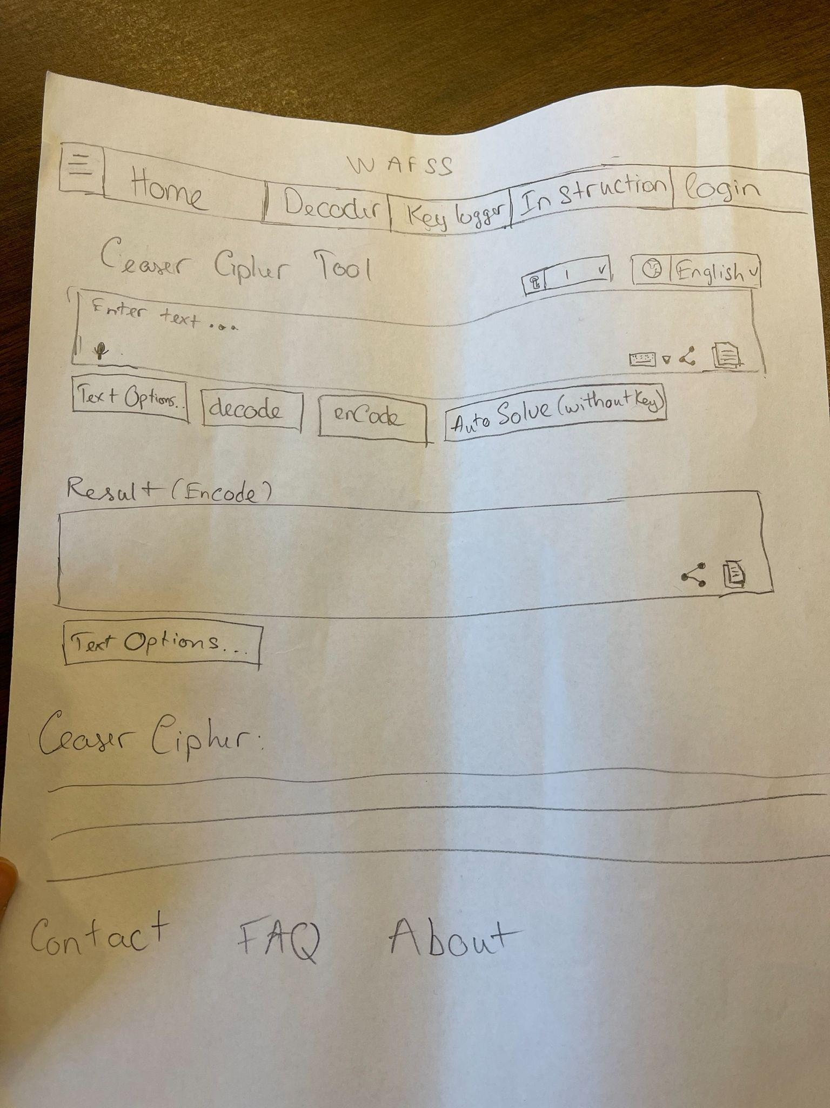

**Glossary of Terms**

| Terms | Definition |
| --- | --- |
| Internet Protocol (IP) | The set of rules governing the format of data sent via the internet or local network |
| Microservice model | Architectural and organizational approach to software development |
| Operating System (OS) | Software that controls the operation of a computer and directs the processing of programs |
| Processor (CPU) | Logic circuitry that responds to and processes the basic instructions that drive a computer |
| Random access memory (RAM) | Computer's short-term memory, which it uses to handle all active tasks and apps |
| Video Graphics Array (VGA) | Computer chipset standard for displaying color graphics |
| WAFSS | Web Applications for Security Study |

References:

Jimholtz. (n.d.). Web application requirements - power platform. Power Platform | Microsoft Docs. Retrieved February 22, 2022, from https://docs.microsoft.com/en-us/power-platform/admin/web-application-requirements

Google. (n.d.). System requirements. Google Web Designer Help. Retrieved February 22, 2022, from https://support.google.com/webdesigner/answer/3232604?hl=en